Polygon Yahtzee
UPPER SECTION |  | HOW  TO SCORE | Game  # 1 | Game  # 2 | Game  # 3 | Game  # 4 | Game  # 5 | Game  # 6
Triangles 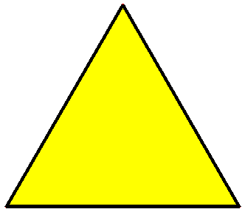 = 3 |  | Count and Add Only Triangle
Quadrilateral  = 4 |  | Count and Add Only Quadrilateral
Pentagon 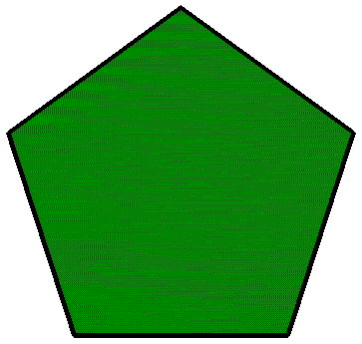 = 5 |  | Count and Add Only Pentagon
Hexagon 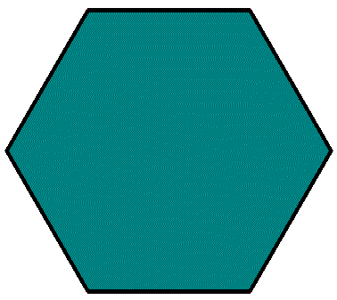 = 6 |  | Count and Add Only Hexagon
Octagon 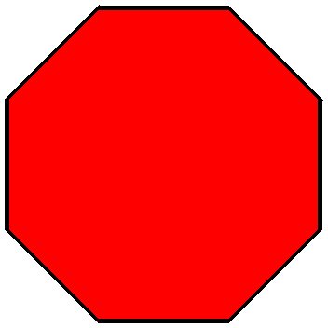 = 8 |  | Count and Add Only Octagon
Decagon 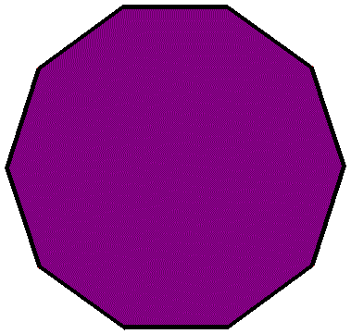 = 10 |  | Count and Add Only Decagon
Total Score
Bonus | If total score | Score 60
Bonus | is 108 or over
TOTAL | Of Upper
TOTAL | Section
Lower Section
Odds: Triangles or Pentagon |  | Only Add Odd Sided Shapes
Evens: Quadrilateral, Hexagon, Octagon, Decagon |  | Only Add Even Sided Shapes
Full House | 2 same odds / 3 same evens | Score 30
Full House | 2 same evens / 3 same odds
Small Straight | Sequence of 4 | Score 40
Small Straight | T,Q,P,H / Q,P,H,O / P,H,O,D
Large Straight | Sequence of 5 | Score 50
Large Straight | T,Q,P,H,O / Q,P,H,O,D
Yahtzee | 5 of | Score 75
Yahtzee | A kind
Chance |  | Score Total
 |  | Of All 5 Dice
Total | Of Lower
Total | Section
Total | Of Upper
Total | Section
Grand Total

