SMART Board User Group

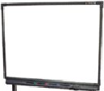

SMART Board User Group

SMART Board User Group

SMART Board User Group

